OpenSearch Benchmark

#Critical Thresholds to Watch  
CPU Utilization: > 80% sustained  
JVM Memory Pressure: > 85%  
Storage Utilization: > 85%

CPU and Memory utilization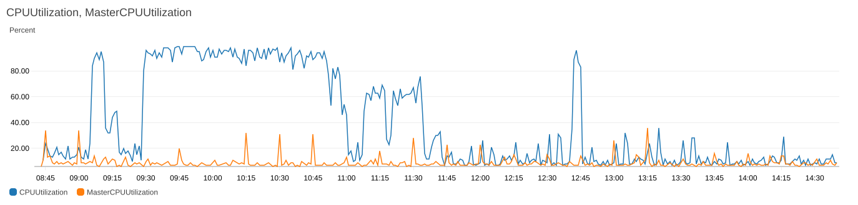

JVM memory pressure and Master JVM memory pressure

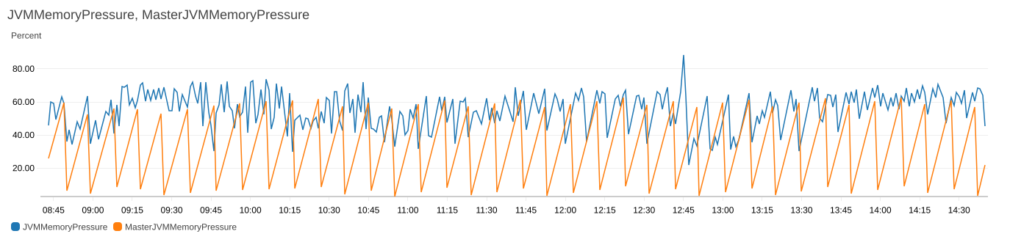

Indexing Latency and Search Latency

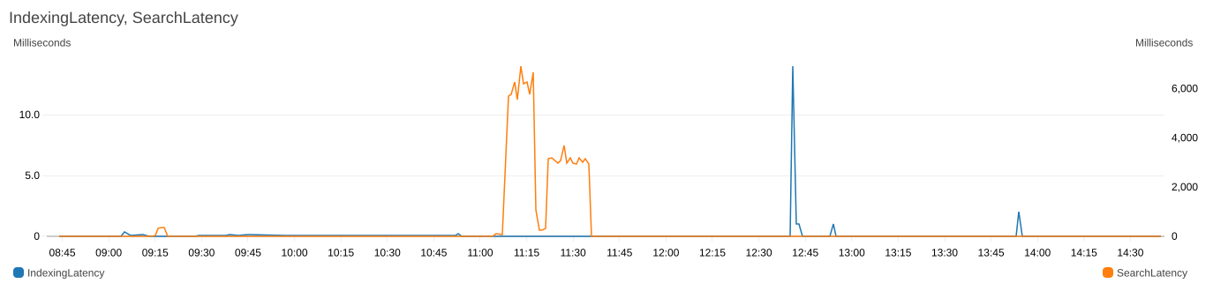

Indexing Rate and Search Rate

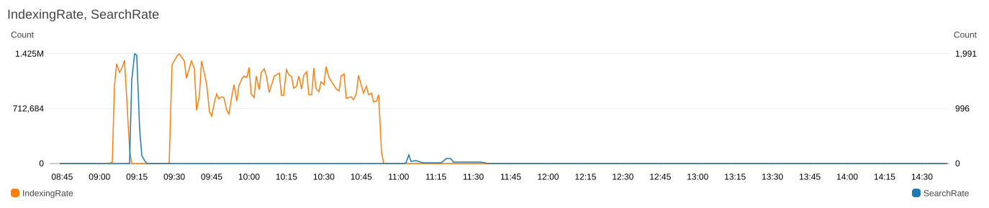

Free Storage Space

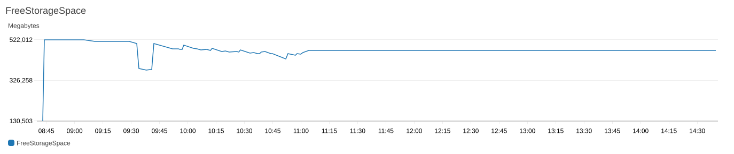

The ones below are during resilience test.

This is when we brought a node down

Shard reassigning ones the new node is back

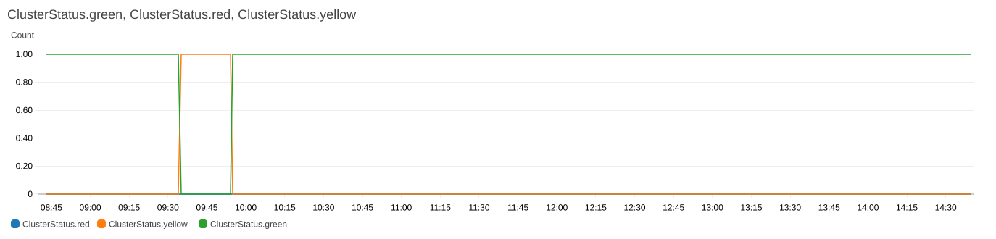

Testing node reachability – this is also time it took to restart the node (replicate node drop)

Master Reachable from Node, Nodes

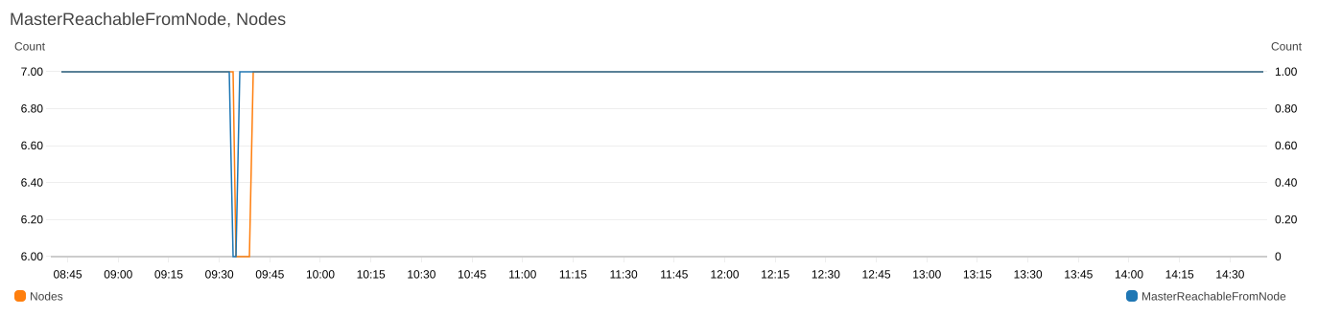

Just few 4xx during this time and no 5xx errors

